# myACCESS Connectivity Requirements

**Version 1.0**

**Release Date: 25.11.2021**

myACCESS is using the OpenVPN technology in behind. There are two layers of connections, first (Phase 1) is connection between the client/device and a central server using OpenVPN technology.

If you use myACCESS VPN Client on your computer, then there is one more step (Phase 2) which creates a link between the end device and your computer. This Phase 2 links the local network on the end device with your computer.

## Connection Stability - requirements

To make the connection to myACCESS reliable, there are some requirements which should be fulfilled. Most importantly, make sure your devices have a stable connection to the internet. Latency above 50ms on fixed network or 500ms on LTE network will most likely result in unreliable service. Also, there should be no packet lost on the connection to the internet.

Complete list of requirements can be found here: <https://www.myscada.org/mybox8-manual/?section=operational-conditions>

## Connecting New End Device to the myACCESS – Guide

Complete manual can be found here: <https://www.myscada.org/myaccess-manual/?section=introduction-21>

Before you connect, please do the following internet connectivity check.

### myBOX

1. Go to the settings page of myBOX and log in:

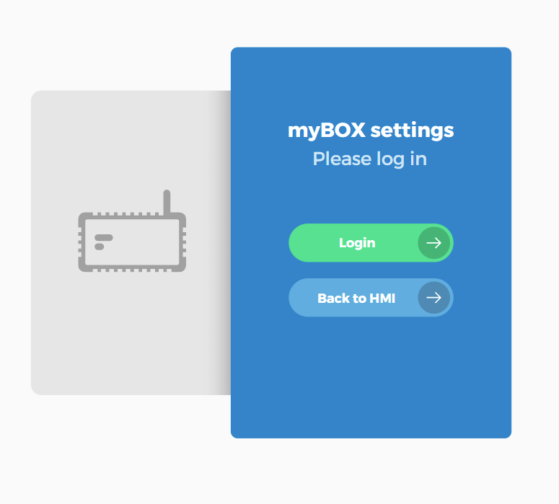

1. Click on the Debug -> Ping menu

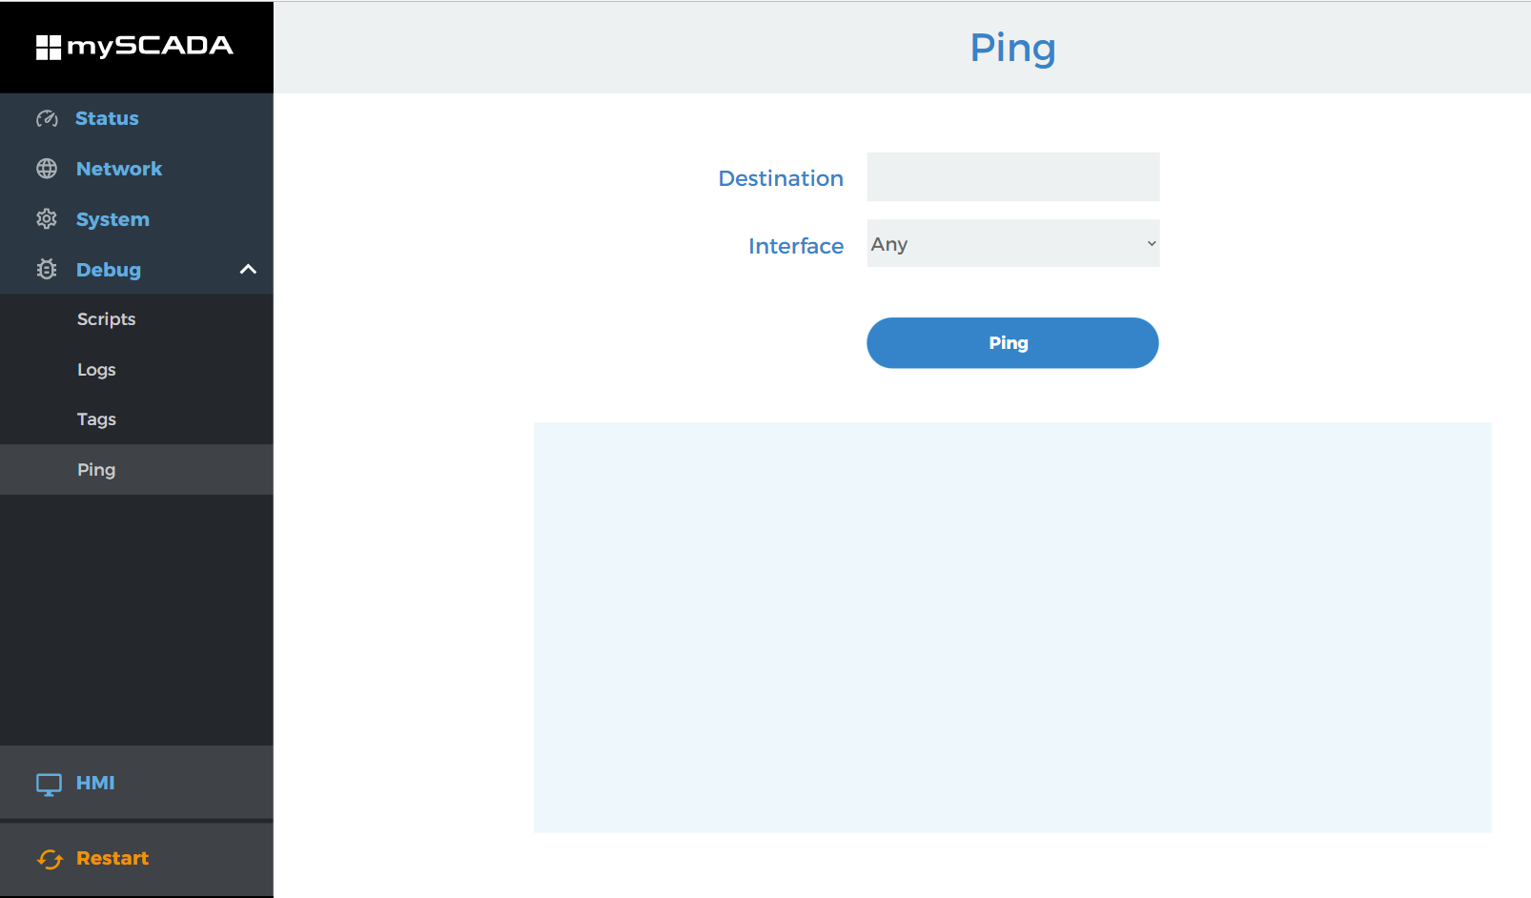

1. Enter the ping destination, it can be any address on the internet (Domain address preferably). It can be for example the **myscada.org** address

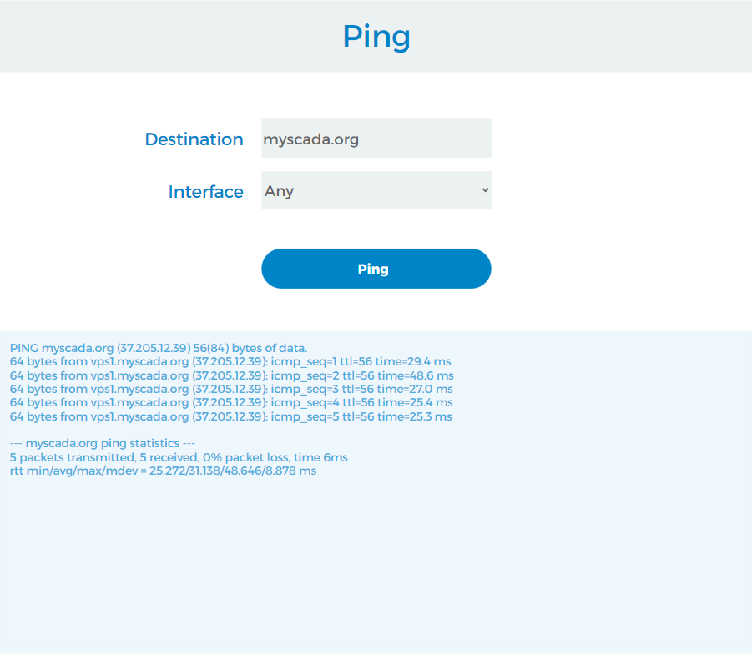

1. Evaluate the result. Look at the “ping statistics”.

First part tells you if there are any dropped packets. Number of packets transmitted must be the same as packets received.

**5 packets transmitted, 5 received, 0% packet loss**

Also, please check that all pings response times are bellow

1. On wired connection 50ms
2. Oo LTE/5G connection bellow 500ms

**64 bytes from vps1myscada.org: icmp_seq=5 ttl=56 time=25.3 ms**

### LTE as Backup Mode:

If you’re using LTE connection as a backup, make sure that the wired Ethernet connection will be present otherwise it will cause myACCESS to disconnect periodically according to the watchdog timer set (As example watchdog 5 min will cause that each 5 minutes myBOX to disconnect LTE connection and check if there is a connection on the Ethernet if not it will switch back to LTE and this process will be repeated until there will be connection on the ethernet).

### Windows Computer

1. Open the terminal
2. Enter into the console ping **myscada.org**
3. Evaluate the result. Look at the “ping statistics”.

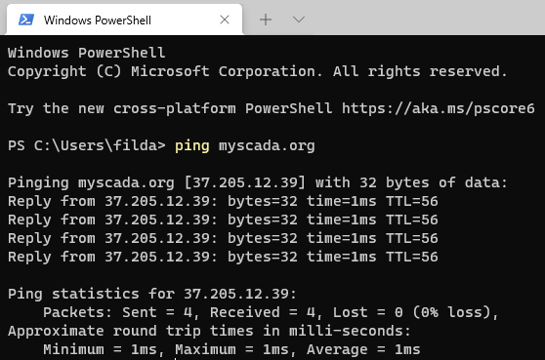

First part tells you if there are any dropped packets. Number of packets transmitted must be the same as packets received.

**5 packets transmitted, 5 received, 0% packet loss**

Also, please check that all pings response times are bellow

A} On wired connection 50ms

B} On LTE/5G connection below 500ms

**Reply from myscada.org(37.205.12.39): bytes=32 time=1ms TTL=56**

## Ensuring the VPN traffic Comes Through

To make sure the device can connect to the myACCESS VPN server, you should enable traffic on the firewall according the following guide:

When adding a device to the myACCESS Portal, you specify the port to use. Based on the selected port, make sure this port is open for network traffic with following parameters:

**Port**:

**Default**: Open port 1201

**80**: will try to tunnel communication over port 80 (use in restrictive networks where other ports are blocked)

**443**: will try to tunnel communication over port 80 (use in restrictive networks where other ports are blocked)

**1194**: Use this port if network admin enabled standard OpenVPN communication.

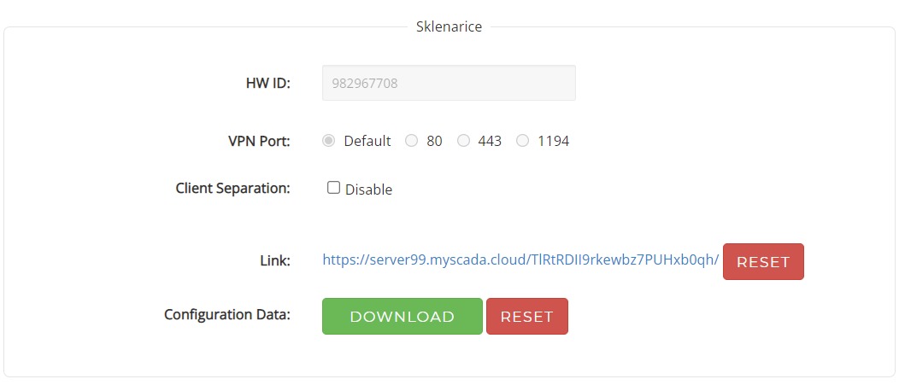

**Network connection type: TCP**

**Packets: OpenVPN**

Optimally, you should use the “Default” option for the port. In case the connectivity is not possible even using the 1194 port, you can use the tunneling over 80 or 443 as those ports are usually open even in restrictive networks.

## Whitelisting the myACCESS servers

We recommend to whitelist the myACCESS servers on your network. Following server domain names are used when using myACCESS:

|  |  |
| --- | --- |
| Server domain name | IP Address |
| vps1.myscada.org | 37.205.12.39 |
| server99.myscada.cloud | 37.205.14.244 |